II Международный марафон
«Удивительный мир английского языка»
Ответы для учащихся 4 классов

Ответ должен быть представлен строго в виде НОМЕРА ВЕРНОГО ОТВЕТА (1 или 2 или 3 или 4) без дополнительных символов. Пожалуйста, не вписывайте ответ СЛОВАМИ, только НОМЕР верного ответа! Неверно записанные ответы не учитываются.

№ | Вопрос | Иллюстрация | Варианты ответов
1 | Look at the picture. What is Ann good at? |  | 1) She’s good at cooking.  2) She’s good at dancing.  3) She’s good at drawing.  4) She’s good at swimming.
2 | Find the word with the similar meaning for:  awful | 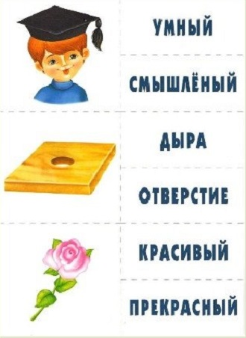 | 1) beautiful  2) terrible  3) funny  4) dangerous
3 | Guess a riddle:  What do cats have that no other animals have? | 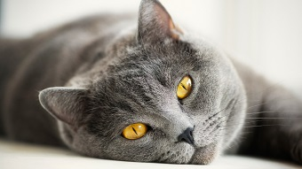 | 1) legs  2) kittens  3) apples  4) tail
4 | Which month is the coldest in Russia? | 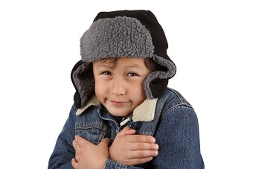 | 1) July  2) October  3) March  4) December
5 | Finish the sentence:  The 7th of January is … |  | 1) the first day of school.  2) Christmas in England.  3) Christmas in Russia.  4) the New Year.
6 | Who is this fairytale character?  He is little. He is funny. He is pink. His best friends are Christopher Robin and Teddy bear. | 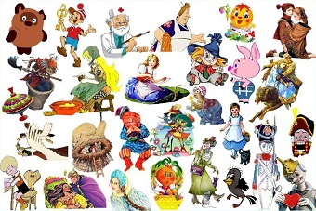 | 1) Jerry  2) Mickey Mouse  3) Piglet  4) Mowgli
7 | Choose the correct word:  Is … your pen over there? |  | 1) these  2) that  3) this  4) those
8 | Name one of New York symbols. |  | 1) The Statue of Liberty  2) Big Ben  3) The Eiffel Tower  4) Trafalgar Square
9 | Choose the correct option:  Box A is bigger than box B, box C is bigger than box A. | 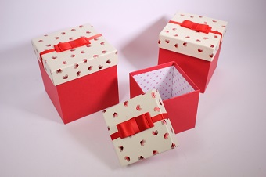 | 1) Box A is the biggest box.  2) Box B is the smallest box.  3) Box C is the smallest box.  4) Box B is the biggest box.
10 | Complete the proverb:  There is no place like … |  | 1) school  2) library  3) home  4) shop
11 | Students read about the countries of the world in this subject. | 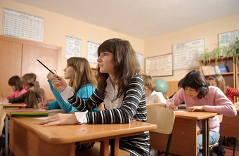 | 1) Maths  2) English  3) History  4) Geography
12 | Choose the correct adjective.  Linda is … student in her class. |  | 1) better  2) bad  3) the best  4) good
13 | Who comes at night and brings a present when a child looses a tooth? | 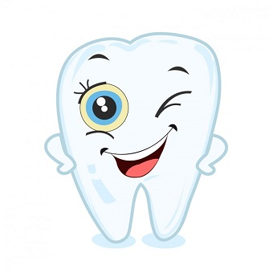 | 1) Santa Claus  2) Tooth fairy  3) Easter Rabbit  4) Harry Potter
14 | Find the proper form of the plural for:  child | 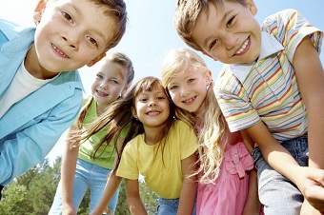 | 1) childhood  2) childs  3) childrens  4) children
15 | Choose a rhyme to:  believe | 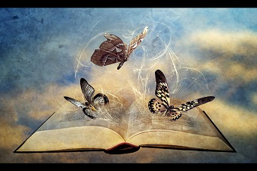 | 1) life  2) leave  3) melon  4) brave
16 | Insert the proper word:  The Sahara is one of the hottest … in the world and it's in Africa. | 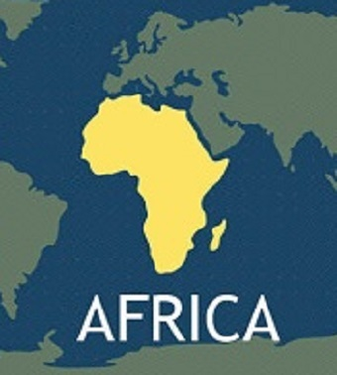 | 1) mountains  2) deserts  3) continents  4) oceans
17 | Who wrote “Alice's Adventures in Wonderland”? | 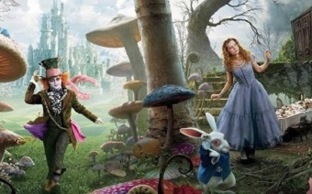 | 1) Mark Twain  2) Daniel Defoe  3) Lewis Carroll  4) Joanne Rowling
18 | Choose the word with the following sound:  [au] |  | 1) snow  2) hall  3) town  4) look
19 | Guess, what?  It is not a tree, but has leaves;  It is not a dress, but is sewn together;  It has no tongue, but can tell you a story |  | 1) copy-book  2) book  3) film  4) teacher
20 | Complete the sentence:  For Christmas dinner the English usually have ... . | 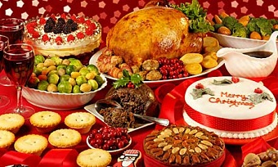 | 1) chicken  2) turkey  3) fish  4) roast beef
21 | Which preposition do you use with months? | 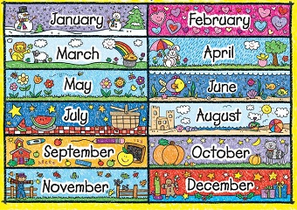 | 1) on  2) at  3) in  4) by
22 | Choose the correct answer.  What’s the weather like today? | 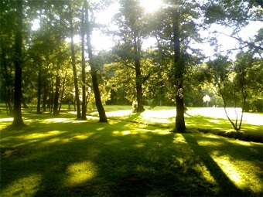 | 1) It’s half past twelve.  2) It’s warm and sunny.  3) I don’t like eggs for breakfast.  4) It’s very dark in the room.
23 | Look at the picture and answer the question:  What is their favorite sport? |  | 1) hockey  2) skating  3) cycling  4) curling
24 | Insert the correct modal verb:  You … eat so much chocolate. It’s not good for you. | 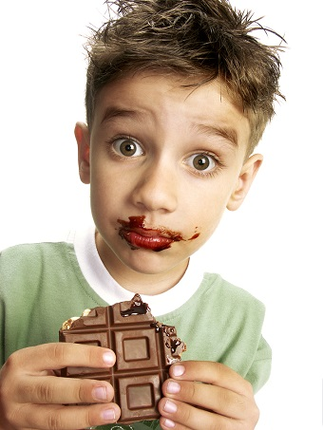 | 1) should  2) shouldn’t  3) can  4) can’t
25 | Find the sentence with a mistake. |  | 1) I wore shorts yesterday.  2) They was in London 2 days ago.  3) They read a book the day before yesterday.  4) She went to the theatre last month.

